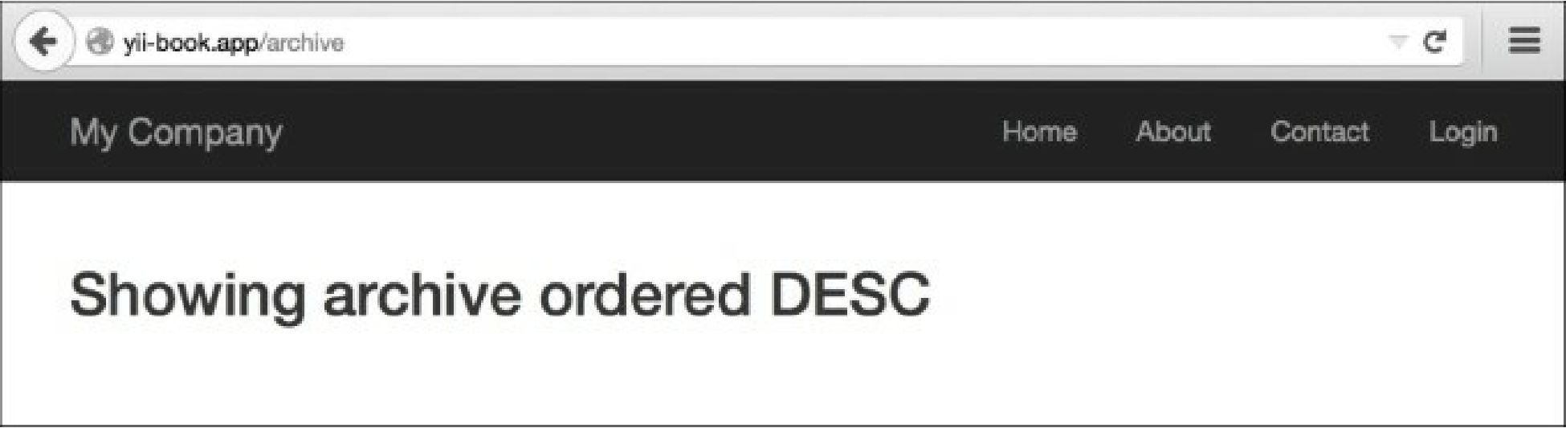

The following screenshot shows that the URL http: //yii-book. app/archive/test did not run successfully and encountered an error:

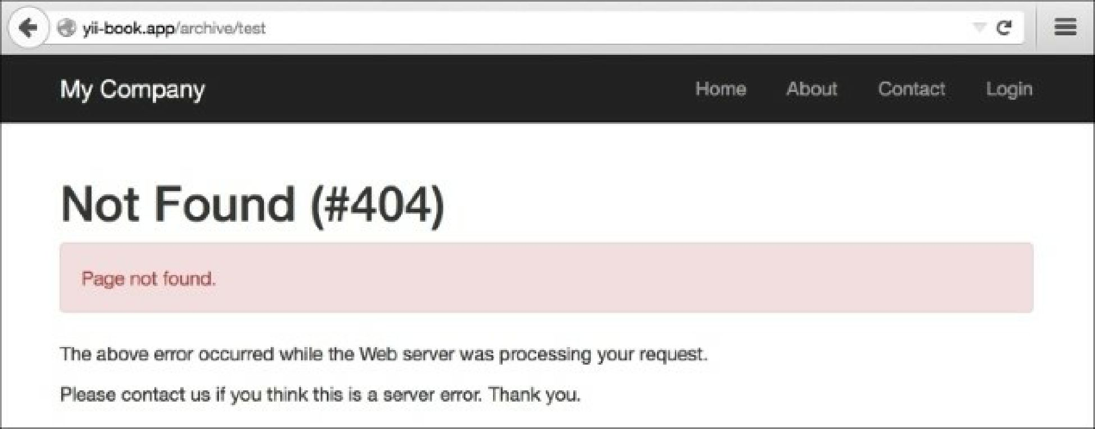

How it works...

You can use regular expressions in both the parameter definition and the rest of the rule. Let’s read our rules one by one:

'post/<alias:[-a-z]+>' => 'post/view',

The alias parameter should contain one or more English letters or a dash. No other symbols are allowed. '(posts|archive)' => 'post/index',

'(posts|archive)/<order:(DESC|ASC)>' => 'post/index',

Both posts and archive lead to post/index. The order parameter can only accept two values—desc